IDENTIFYING FIRE DRIVERS IN THE PARAGUAYAN CHACO, PARAGUAY: MACHINE LEARNING ANALYSIS OF CLIMATE, LAND USE CHANGE, AND ECOSYSTEM RISK

by

Paulo Caetano Medina Avalos

Thesis submitted to the Faculty of the Graduate School of the
University of Maryland, College Park, in partial fulfillment
of the requirements for the degree of
Master of Science in Geospatial Information Sciences
2026

Mentors:
PhD, Evan Ellicott
PhD, Jianguo Ma

Table of Contents

Table of Contents iii
List of Tables v
List of Figures vi
List of Abbreviations vii
1. INTRODUCTION 1
2. LITERATURE REVIEW 3
2.1. Fire Regimes and Drivers in Agricultural Landscapes 3
2.1.1. Fire as a Landscape Process 3
2.1.2. Agricultural Fire and Deforestation-Fire Feedback 3
2.1.3. Fire Regimes in the Gran Chaco 4
2.2. Fire Regime Transitions and Land Use Change 5
2.2.1. Temporal Dynamics of Fire Following Deforestation 5
2.2.2. Fire Regime Characteristics: Frequency, Size, and Seasonality 5
2.3. Spatial Fire Risk Assessment Frameworks 6
2.3.1. Defining Fire Risk: Hazard, Exposure, Vulnerability 6
2.4. Modeling Fire Ignition Probability 7
2.4.1. Drivers of Fire Ignition 7
2.4.2. Machine Learning Approaches for Ignition Prediction 8
2.4.3. Model Comparison and Performance Evaluation 8
2.5. Fire Driver Attribution and Separation 8
2.5.1. Climatic vs. Anthropogenic Fire Drivers 8
2.5.2. Feature Importance and Interpretable Machine Learning 9
2.5.3. SHAP Values for Model Interpretation 9
2.5.4. Spatial and Temporal Patterns of Driver Dominance 9
2.6. Synthesis and Research Gap 10
3. STUDY AREA 12
3.1. Geographic Context and Ecoregions 12
3.2. Climate and Fire Seasonality 13
3.3. Land Use and Fire Regime 15
3.4. High-Value Assets at Risk 16
4. DATA 17
4.1. Fire Occurrence and Burned Area Data 18
4.2. Climatic Variables 18
4.3. Vegetation Indices 19
4.4. Land Cover and Land Use Change Data 19
4.5. Topographic Variables 20
4.6. Anthropogenic Variables 20
4.7. Protected Areas and Forest Data 20
4.8. Data Processing and Preparation 21
4.9. Summary 21
5. METHODS 23
5.1. Fire Ignition Probability Modeling (Random Forest) 23
5.1.1. Predictor Variable Selection 23
5.1.2. Model Training and Validation 23
5.1.3. Model Performance Evaluation 24
5.1.4. Fire Probability Surface Generation 24
5.2. Land Use Conversion Analysis 25
5.2.1. Identifying Conversion Zones 25
5.2.2. Temporal Window Classification 25
5.2.3. Spatial Stratification by Conversion Intensity 26
5.3. Fire Regime Characterization 26
5.3.1. Fire Frequency Calculation 26
5.3.2. Fire Size Distribution Analysis 27
5.3.3. Seasonal Pattern Analysis 27
5.3.4. Recurrence Interval Estimation 28
5.4. Driver Attribution Analysis 28
5.4.1. SHAP Value Calculation 28
5.4.2. Global Feature Importance Analysis 29
5.4.3. Spatial Patterns of Driver Dominance 29
5.5. Ecosystem Vulnerability 30
5.5.1. High-Value Asset Classification 30
5.5.2. Forest Exposure Metrics 31
5.5.3. Vulnerability Scoring 32
5.6. Integrated Risk Assessment 33
5.6.1. Risk Map Generation 33
6. RESULTS 37
6.1. Fire Ignition Model Performance 37
6.2. Fire Spread Model Calibration and Validation 37
6.3. Burn Probability Surfaces 37
6.4. Vulnerability Assessment Outputs 37
6.5. Integrated Risk Maps 37
6.6. Uncertainty Analysis 37
7. DISCUSSION 37
7.1. Model Performance and Validation 37
7.2. Spatial Patterns of Fire Risk 37
7.3. Implications for Fire Management 37
7.4. Limitations and Future Research 37
8. CONCLUSIONS 37
7. BIBLIOGRAPHY 38

List of Tables
Table 1. Summary of datasets used in the fire occurrence modeling and risk assessment framework. 22
Table 2. Temporal window classification keys. 25
Table 3. Spatial conversion intensity classes. 26
Table 4. Vulnerability classes. 33
Table 5. Risk classes. 34

List of Figures
Figure 1. Fire triangles across different scales (Cochrane and Ryan 2009). 3
Figure 2. Fire Hotspot count in the Paraguayan Chaco 2015-2025 – VIIRS NASA. The dashed line indicates mean annual occurrence (23,605 detections). 4
Figure 3. Fire occurrences before and after land use change in all the Chaco Region countries (Baumann et al. 2026) 6
Figure 4. Fire Risk Assessment framework (Rivière et al. 2023) 7
Figure 5. Study area within the Gran Chaco ecoregion, Paraguay. 12
Figure 6. Mean Total Precipitation and Mean Air Temperature (Kacic 2021). 14
Figure 7. Spatial distribution of fire activity in the Paraguayan Chaco, 2015–2024. Kernel density estimation based on VIIRS active fire hotspots. Higher density (red) indicates areas of concentrated fire occurrence; lower density (yellow) indicates areas with sparse fire activity. 15
Figure 8. Land cover change in the Paraguayan Chaco, 2000–2023. (Left) Predominantly intact forest cover in 2000, with limited agricultural clearings. (Right) Extensive deforestation and agricultural expansion by 2023, particularly in the central and northern regions. Pasture (tan) and agriculture (pink) have replaced large areas of forest (dark green). Data source: MapBiomas Paraguay Project, Collection 9 (2026). 16
Figure 9. Spatial distribution of high-value assets in the Paraguayan Chaco. (Left) Population density derived from household data (INE Paraguay 2022 Census). (Right) Indigenous community lands and protected areas (IUCN categories and UNESCO-MAB Biosphere Reserve). 17
Figure 10. Data processing workflow. 18

List of Abbreviations
HVA: High Value Asset
GIS: Geographic Information Sciences

INTRODUCTION
Fires are a natural and recurrent earth system process, with wide impacts on different aspects of the earth's ecological, atmospheric, and geological composition (Bowman et al. 2009). Although these natural occurrences are understood, changes in land cover driven by the expansion of the agricultural and livestock ranching frontier, as well as climate change, have altered these fire regimes, resulting in threatened biodiversity, ecosystemic services, and rural communities (Shlisky et al. 2009).

Within this global context, Paraguay is at the forefront of accelerated deforestation and is one of the hotspots for fires in South America, even surpassing Brazil in fire density during 1999–2015, with most fires concentrating in the Paraguayan Chaco region. The Paraguayan Chaco region contains two ecoregions of the South American Gran Chaco, considered the world’s largest dry forest and second largest forest in South America after the Amazon. This region is considered a biodiversity hotspot and functions as an important biological corridor for faunal species (Baumann et al. 2026). In recent decades, the Paraguayan Chaco has lost over 30% of its original woodland cover, and the livestock and agriculture frontier expands at accelerated rates (Gill et al. 2020).

Fire activity in the Paraguayan Chaco in particular and in the South American Chaco in general is deeply related to anthropic activities, with fire seasonality being related to both climatic conditions and pasture management cycles and clearing practices. In the Paraguayan Chaco, fire is used both as a clearing tool to prepare land for agriculture and implanted pasture, and as a pasture management tool to promote regrowth (Ferro et al. 2026; Magliocca et al. 2022).

These fires threaten biodiversity, the structure of remaining unaltered forests in protected areas, indigenous communities through fire exposure and destruction of sources of subsistence, and infrastructure. The fragmented landscape pattern of the Paraguayan Chaco creates greater exposure of forest edges, making remaining forests less resilient and more fire-prone (Armenteras et al. 2013). In the sparsely populated Paraguayan Chaco, fires affect communities through respiratory illnesses, disruption in state services and general threats to livelihoods (Jasser et al. 2021). Additionally, the Paraguayan Chaco houses the only self-isolated indigenous community of Paraguay, which subsists through the Dry Chaco forests along the border with Bolivia (Gill et al. 2020).

However, a knowledge gap remains in fire impacts and vulnerabilities in the Paraguayan Chaco, with most of the research focused on the neighboring countries (Vidal-Riveros, Currey, et al. 2024). Research in the Paraguayan Chaco has mostly focused on identifying fire regimes, spatio-temporal patterns, and climatic interactions, with little literature identifying vulnerable assets throughout the region.

This project addresses that gap through an integrated fire risk assessment framework combining Random Forest ignition prediction, Cellular Automata fire spread simulation, and Analytical Hierarchy Process (AHP) vulnerability assessment to produce probabilistic fire risk maps for the Paraguayan Chaco. Specifically, this research answers the question: Where are the most vulnerable forests, communities, and infrastructure located, and what is their level of fire risk?

The high value assets (HVA) considered in this project are communities, forests, and infrastructure.
More specifically, the objectives of this research are:

- Develop and validate a fire ignition probability model using Random Forest at 500 m spatial resolution, trained on dry season (May-October) fire occurrences for 2015-2024 and validated on the 2025 dry season to identify spatial patterns of seasonal fire risk.

- Simulate fire spread dynamics using a Cellular Automata model at 500 m spatial resolution with Monte Carlo simulations, calibrated against MapBiomas Fuego burn scars to generate seasonal burn probability surfaces and quantify uncertainty in fire spread trajectories.

- Assess the vulnerability of high-value assets (communities, forests, infrastructure) to fire hazards by developing composite vulnerability indices that integrate exposure (spatial proximity to fire-prone areas), sensitivity (asset characteristics influencing damage potential), and adaptive capacity (ability to withstand or recover from fire impacts).

- Integrate ignition probability, burn probability, and asset vulnerability into spatially-explicit fire risk maps using Analytical Hierarchy Process (AHP) weighting, with Monte Carlo simulation propagating uncertainty from individual model components through the final risk assessment.

LITERATURE REVIEW

Fire Regimes and Drivers in Agricultural Landscapes

Fire as a Landscape Process
Fire is understood to be a natural and recurrent earth system process, contributing to the delineation of ecological boundaries, influencing geological cycles, and affecting atmospheric dynamics (Bowman et al. 2009; Harrison et al. 2021; Shakesby and Doerr 2006).

Fire requires fuel, oxygen, and heat; at landscape scales these translate to vegetation, weather, and ignition sources (Cochrane and Ryan 2009). Cochrane and Ryan's multi-scale fire triangle framework (Figure 1) illustrates how these elements vary across temporal and spatial scales, with topography, fuel characteristics, and climate driving fire behavior at the landscape level.
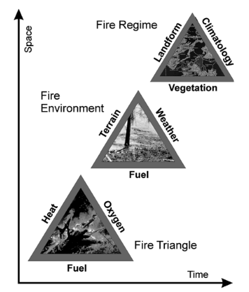
Figure 1. Fire triangles across different scales (Cochrane and Ryan 2009).

Agricultural Fire and Deforestation-Fire Feedback
These fire elements are heavily influenced by human activity through both direct ignition and landscape modification. Land use change—particularly deforestation driven by agricultural expansion—disrupts fuel continuity, increases forest edge exposure, and alters microclimatic conditions, creating landscapes more susceptible to fire spread (Balch et al. 2009; Shlisky et al. 2009). Globally, deforestation, agriculture, and rural and urban development are recognized as the major drivers of fire regime alteration (Shlisky et al. 2009).

Fire is also actively used as a land management tool. In the South American Gran Chaco ecoregion, both small-scale and large-scale landowners employ fire to facilitate grass regeneration, eliminate pests, control shrub encroachment, and prepare land for agricultural conversion following deforestation (Ferro et al. 2026). This dual role—fire as both consequence and tool of agricultural expansion—creates a positive feedback: deforestation fragments forests, increasing fire susceptibility, which in turn facilitates further conversion of fire-degraded landscapes (Armenteras et al. 2013).

Fire Regimes in the Gran Chaco
The Gran Chaco is a vast sedimentary plain extending across Argentina, Paraguay, Bolivia, and Brazil, dominated by dry broadleaf tropical forests that support high faunal and floral diversity. The region is divided into two main ecoregions: 1) the Wet Chaco and 2) the Dry Chaco, both with distinct fire seasonality patterns (Vidal-Riveros, Reyes, et al. 2024). Fire occurrence is generally concentrated in late winter and early spring following the dry season, driven by the interaction between fuel accumulation during the wet season and low biomass humidity during the dry season (Ferro et al. 2026).

Figure 2. Fire Hotspot count in the Paraguayan Chaco 2015-2025 – VIIRS NASA. The dashed line indicates mean annual occurrence (23,605 detections).
Despite being a biodiversity hotspot and containing the second-largest forest in South America after the Amazon, the Gran Chaco has received relatively limited research attention compared to neighboring ecosystems (San Martín et al. 2023; Vidal-Riveros, Currey, et al. 2024). Recent decades have seen accelerated deforestation driven by agricultural expansion, particularly for soybean cultivation and cattle ranching. Between 2000 and 2012, the Gran Chaco lost over 20 million hectares of forest, with deforestation rates in some areas exceeding those of the Brazilian Amazon (Magliocca et al. 2022; Baumann et al. 2026). This rapid land conversion has created highly fragmented landscapes, increasing forest edge density and fire susceptibility (Armenteras et al. 2013).

In the Paraguayan Chaco specifically, fire activity has been among the highest in South America. Between 2015 and 2025, fire hotspot detections averaged 23,605 occurrences annually, with the 2020 peak reaching 42,549 detections (Figure 2). These fires threaten biodiversity in protected areas such as Defensores del Chaco National Park, disrupt indigenous and rural communities through respiratory illness and livelihood impacts, and damage critical infrastructure (Jasser et al. 2021). Despite this high fire activity, research on fire risk and vulnerability in the Paraguayan Chaco remains limited, with most South American fire studies concentrated in the Brazilian Amazon, Argentine Chaco, and Bolivian Chiquitanía (Vidal-Riveros, Reyes, et al. 2024).

Fire Regime Transitions and Land Use Change

Temporal Dynamics of Fire Following Deforestation
Land use clearing and land use conversion related fires are the most common type of fire in the tropics. As discussed earlier, fire is a tool used both for clearing and pasture management in the Gran Chaco region and in the tropics in general, with the peak of fire activity coinciding with peak deforestation periods for the entire Chaco region (Baumann et al. 2026; Shlisky et al. 2009). After the clearing period, the management fires dominate the fire activity in the Chaco, with fires aimed to control woody encroachment of pastures (Baumann et al. 2026).

There have been record fire years recently in the South American dry woodland and savannah regions such as the Cerrado, Chiquitano, and Gran Chaco, with many of them showing patterns of related anthropogenic activities. Alongside an intensified agricultural expansion, these regions experience an increasing frequency and severity of droughts and burning (Baumann et al. 2026).

This fire dynamic, dominated by agricultural and livestock activity, has effects on neighboring forests and native shrublands, influencing on future fires by increasing susceptibility and degrading these ecosystems (Shlisky et al. 2009). This feedback loop has been seen in the Brazilian Amazon, where deforestation promotes forest fragmentation, influences regional climatic patterns, increase fire-susceptible forest edges, and promotes species decay which makes the vegetation more flammable (Shlisky et al. 2009; Xu et al. 2020).

Fire Regime Characteristics: Frequency, Size, and Seasonality
Fire regime is the result of the interaction between climate, biophysical modulators, and social drivers (Corona-Núñez and Campo 2023). These interactions are visible in vegetation and fuel load being dependent on weather, which in turn facilitates or suppress fire at the landscape level.

Following this dynamic, it becomes evident that changes in land cover and land use will affect the biophysical modulators directly, and climatic variables indirectly. These changes, driven by agricultural and livestock activities, usually are accompanied by an increase in fire activity as land is being cleared, and a following stabilization after land use has been settled as seen in Figure 3 (Baumann et al. 2026).
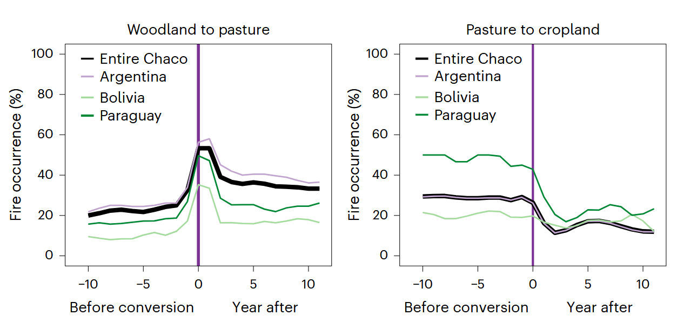
Figure 3. Fire occurrences before and after land use change in all the Chaco Region countries (Baumann et al. 2026)
Evidence from the Gran Chaco region supports a stabilization pattern in many areas. Baumann et al. (2026) found that fire occurrence peaked during active deforestation periods and declined 2-3 years post-conversion as pastures became established and woody encroachment was controlled. This pattern was most pronounced in areas with intensive cattle ranching, where fire is used strategically for pasture renewal rather than continuously for land clearing. However, the same study noted that fire activity remained elevated in zones with ongoing agricultural expansion, suggesting stabilization is conditional on completion of land conversion.

Spatial Fire Risk Assessment Frameworks

Defining Fire Risk: Hazard, Exposure, Vulnerability
Spatial fire risk is assessed considering the likelihood of a fire event occurring, the hazard it poses on a given asset, the exposure of these assets, and the vulnerability of the assets facing the fire event. Risk is quantified by weighting and combining these components, with weighting approaches varying based on assessment objectives and data availability (Oliveira et al. 2021; Chuvieco et al. 2010).

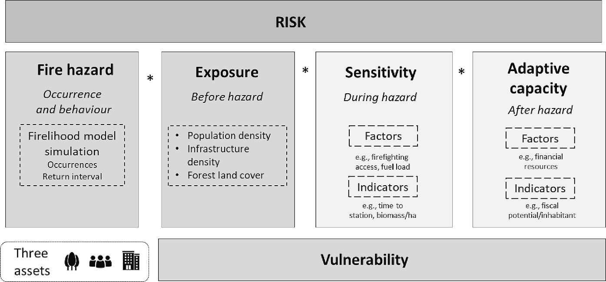
Figure 4. Fire Risk Assessment framework (Rivière et al. 2023)
Fire hazard quantifies the spatiotemporal likelihood and intensity of fire events, comprising two distinct processes: ignition (where fires start) and spread (where fires propagate). Ignition is typically modeled using statistical or machine learning approaches that relate environmental and anthropogenic variables to historical fire occurrence, while spread is simulated using spatial fire behavior models that account for fuel, topography, and weather conditions (Oliveira et al. 2021; Chuvieco et al. 2010).

Exposure evaluates the spatial location of valued resources and assets (HVRAs) and fire-prone areas. This is quantified by overlaying HVRA locations with hazard probability surfaces derived from ignition and spread models, producing spatial exposure metrics for different asset types (Oliveira et al. 2021). Vulnerability quantifies the susceptibility of exposed HVRAs to fire damage, incorporating both intrinsic sensitivity (e.g., flammability of forest types, structural resistance of infrastructure) and adaptive capacity (e.g., fire suppression resources, community preparedness) (Rivière et al. 2023).

Modeling Fire Ignition Probability

Drivers of Fire Ignition
Fire ignition in wildland landscapes occurs through both natural and anthropogenic pathways. Natural ignition sources, primarily lightning strikes, dominate in remote ecosystems with minimal human presence (Giglio et al. 2018). However, in human-modified landscapes anthropogenic ignition sources predominate, driven by deliberate fire use for land clearing, crop residue burning, pasture management, and accidental ignitions from infrastructure and human activity (Oliveira et al. 2012).

In the South American Gran Chaco region, fires are mostly linked to anthropogenic activities, particularly due to deforestation and pasture management. Fire is intentionally used for deforestation, pasture renovation, and shrubland clearance, with ignition frequency closely tied to proximity to agricultural areas, roads, and settlements (Ferro et al. 2026; Magliocca et al. 2022; Baumann et al. 2026).

Machine Learning Approaches for Ignition Prediction
Fire ignition modeling traditionally relied on statistical approaches such as logistic regression and generalized linear models to relate environmental and socioeconomic variables to historical fire occurrence (Rodrigues and de la Riva 2014). However, these parametric methods assume linear or predefined relationships between predictors and fire occurrence, limiting their ability to capture complex interactions (Oliveira et al. 2012).

Machine learning addresses these limitations by handling complex non-linear relationships, automated pattern recognition, and relatively higher predictive accuracy. Among machine learning approaches, Random Forest (RF) has become the most widely adopted method for fire ignition prediction due to its robustness, interpretability, and performance across diverse fire regimes (Mihajlovski and Zhiyanski 2025). RF is an ensemble decision tree method that handles nonlinear predictor relationships, accommodates mixed data types (continuous climatic variables, categorical land cover classes, spatial metrics), and provides variable importance measures that identify key ignition drivers (Rodrigues and de la Riva 2014; Giglio et al. 2018).

Gradient boosting methods, particularly XGBoost and LightGBM, have emerged as competitive alternatives to Random Forest for fire prediction tasks. These methods build sequential ensembles of decision trees where each tree corrects errors from previous trees, often achieving higher predictive accuracy than Random Forest's parallel ensemble approach (Illarionova et al. 2025). XGBoost handles imbalanced datasets (fire vs. non-fire presence) more effectively through built-in class weighting and has shown superior performance in fire prediction studies across diverse ecosystems. However, gradient boosting methods are more prone to overfitting and require careful hyperparameter tuning compared to Random Forest's relatively robust default settings (Bihari et al. 2025).

Model Comparison and Performance Evaluation
Performance evaluation for fire prediction models requires multiple complementary metrics due to the inherent class imbalance (fire events are rare relative to non-fire locations). The Area Under the Receiver Operating Characteristic Curve (AUC-ROC) provides a threshold-independent measure of discriminative ability and is the most widely reported metric in fire prediction literature. However, AUC-ROC can be overly optimistic for highly imbalanced datasets. Precision-Recall curves and the Cohen's Kappa coefficient provide more conservative assessments by explicitly accounting for classification errors at different thresholds (Mihajlovski and Zhiyanski 2025).

Fire Driver Attribution and Separation

Climatic vs. Anthropogenic Fire Drivers
As described earlier, fire regimes are the result of the interplay of fuel resources, fire weather conditions, topography, and natural or anthropogenic ignitions. Understanding the role of each element as a fire driver is key to guide fire risk and thus mitigation efforts (Zhang et al. 2023).

Following this endeavor, there are two main approaches to wildfire control attribution modeling: a) process-based fire-enabled dynamic global vegetation models, and b) data-driven statistical models. However, due to the non-linear nature of climatic, topographic, and anthropogenic interactions in fire behavior, machine learning (ML) emerges as a viable option (Zhang et al. 2023).

Feature Importance and Interpretable Machine Learning
While ML methods provide better predictive results, they are still considered black boxes for lack of interpretability, thus, obscuring conclusions regarding the interaction of model inputs with the dependent variable. Additionally, even though ML methods such as RF provide variable importance metrics, these are measured by considering the entire data set and not the calculated for each individual sample, which leaves explaining controlling drivers as a challenge (Wang et al. 2021).

A common approach to overcoming this challenge is permutation feature importance. This approach measures the change degree of a model score, such as RSME, when a given variable is shuffled or removed. However, this method is unable to quantify intrinsic predictive value sign and magnitude for a given change of variable, instead only providing generic operating rules (Zhang et al. 2023).

SHAP Values for Model Interpretation
As a potential solution to this issue different techniques have emerged, such as the Shapley Additive exPlanations (SHAP) or the local interpretable model-agnostic explanations (LIME) (Wang et al. 2021; Zhang et al. 2023). SHAP was originally developed for importance estimation of an individual player in a collaborative team, this its origin as a game-theory based framework (Chen 2021).

The main advantage of SHAP comes from its interpretability, namely:
- Global interpretability: the SHAP value shows the degree of contribution for each explanatory variable, either positive or negative, to the dependent variable.
- Local interpretability: since each observation gets its own SHAP values for each explanatory variable, the reason behind each case’s prediction and its contribution to the predictors become transparent.
- Model agnostic: SHAP framework can be calculated for any ML model.

Spatial and Temporal Patterns of Driver Dominance
Spatial patterns of driver dominance can be mapped by calculating SHAP values for each pixel and comparing the contribution magnitudes of climate variables versus anthropogenic variables. Regions where climatic drivers (precipitation deficit, temperature extremes, low humidity) exceed anthropogenic driver contributions represent climate-dominated fire zones, while areas where human factors (distance to agriculture, road density, land cover type) dominate indicate human-modified fire regimes (Zhang et al. 2023). This spatial decomposition enables fire managers to differentiate between areas where fire risk is primarily weather-dependent versus areas where land use change drives fire occurrence.

Synthesis and Research Gap
Fire risk assessment in human-modified tropical dry forests requires integrating spatial prediction of fire occurrence with analysis of the underlying drivers—climate variability versus anthropogenic land use change. Machine learning methods, particularly Random Forest and gradient boosting algorithms, predict fire probability by capturing complex nonlinear relationships between environmental conditions, land use patterns, and ignition sources (Bihari et al. 2025; Mihajlovski and Zhiyanski 2025). However, predictive accuracy alone is insufficient; understanding which drivers dominate fire occurrence—and how their relative importance varies spatially and temporally—is critical for developing effective fire management strategies and policy interventions (Zhang et al. 2023; Wang et al. 2021).

Recent advances in interpretable machine learning, particularly SHAP (Shapley Additive exPlanations), enable decomposition of fire predictions into individual driver contributions, providing both global feature importance and pixel-level attribution of climate versus anthropogenic controls (Wang et al. 2021). When combined with temporal analysis of fire regime characteristics—frequency, size, seasonality—these methods can distinguish whether observed fire patterns are primarily driven by climatic extremes or by land use change dynamics such as agricultural expansion and deforestation-fire feedbacks (Corona-Núñez and Campo 2023; Baumann et al. 2026).

Despite these methodological capabilities, their application remains limited in South American tropical dry forests. Most fire driver attribution studies focus on temperate forests or the Brazilian Amazon, with relatively few examining the Gran Chaco region despite its status as a global deforestation hotspot (Vidal-Riveros, Currey, et al. 2024). Furthermore, existing Chaco fire studies have primarily characterized fire regimes descriptively or examined climate-fire relationships in isolation, without systematically separating climatic versus anthropogenic driver contributions or analyzing how fire regimes transition during and after agricultural conversion (San Martín et al. 2023; Ferro et al. 2026).

The Paraguayan Chaco specifically remains critically understudied. Recent research has begun documenting fire occurrence patterns and climate relationships (Vidal-Riveros, Currey, et al. 2024), but fundamental questions remain unanswered: What proportion of fire activity is driven by climatic conditions versus land clearing and pasture management? Do fire regimes stabilize after agricultural conversion, or do they remain elevated indefinitely? Which regions show climate-dominated versus human-dominated fire patterns? How has the relative importance of different drivers changed as deforestation has accelerated?

This study addresses these methodological and regional gaps by developing an integrated fire occurrence modeling and driver attribution framework for the Paraguayan Chaco. The framework combines:

- Machine learning fire prediction (Random Forest with potential XGBoost comparison) at 500-meter spatial resolution using 25 years of MODIS+VIIRS fire occurrence data (2000-2025) and comprehensive environmental and anthropogenic predictors.
- SHAP-based driver attribution to decompose fire predictions into climate versus land use contributions, mapping spatial patterns of driver dominance and quantifying temporal trends in driver importance as agricultural expansion has intensified.
- Fire regime transition analysis characterizing how fire frequency, size, and seasonality changes during and after forest-to-agriculture conversion, using MODIS land cover time series to identify conversion zones and track fire regime shifts.

STUDY AREA

Geographic Context and Ecoregions
This study is focused on the Paraguayan Chaco region, located within the South American Gran Chaco, encompassing three of its ecoregions: the Dry Chaco, the Wet Chaco, and the Pantanal (Figure 4). The South American Chaco is considered the world’s largest dry forest, consisting of a mixture of dry forests, savannahs, and wetlands. It extends over Argentina (60%), Paraguay (27%), Bolivia (11%), and Brazil (2%) (Gill et al. 2020).

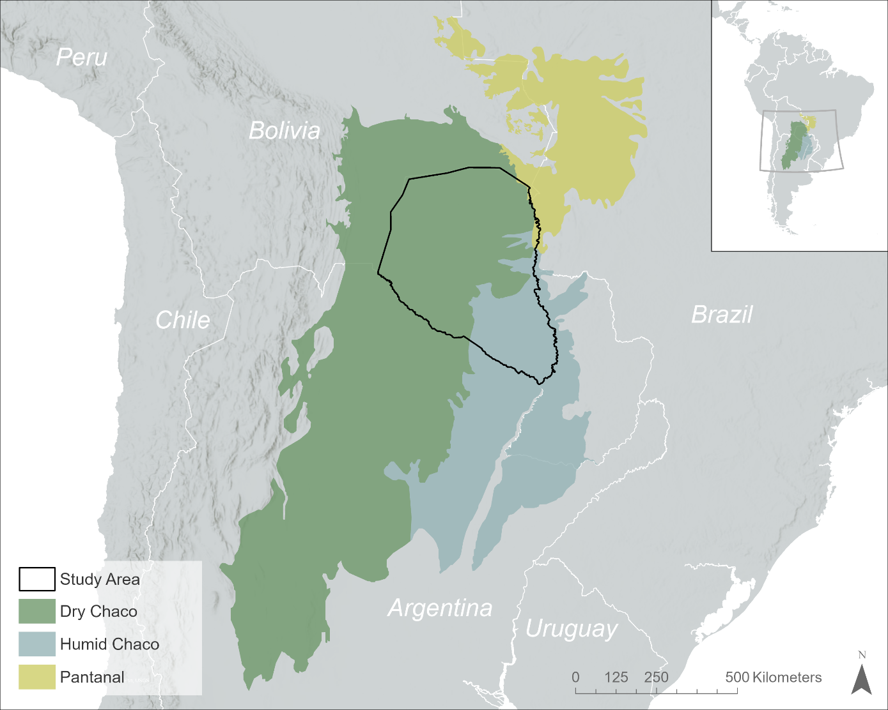
Figure 5. Study area within the Gran Chaco ecoregion, Paraguay.
The Dry Chaco is characterized by dry tropical forests and shrublands covering over half the entire Chaco, with around 175,000 km². The Wet Chaco is covered by floodplains, wetlands, and savannas spanning approximately 63,500 km² . The Paraguayan Chaco also contains a small portion of the Pantanal (1,960 km² ), considered the largest tropical wetland in the world (Gill et al. 2020; San Martín et al. 2023).

Aside from the continental ecoregions, the Paraguayan Chaco is further divided in 5 different ecoregions as shown in Figure 6, representing the variations in weather, vegetation, and topographic conditions. Among these ecoregions, the Medanos region represents one of the last world’s natural territories, providing conservation shelter to endangered mammals such as the yaguareté (Panthera onca), tagua (Catagonus wagneri), tapirs and peccaries and mammals in general (Mereles Haydar et al. 2019).

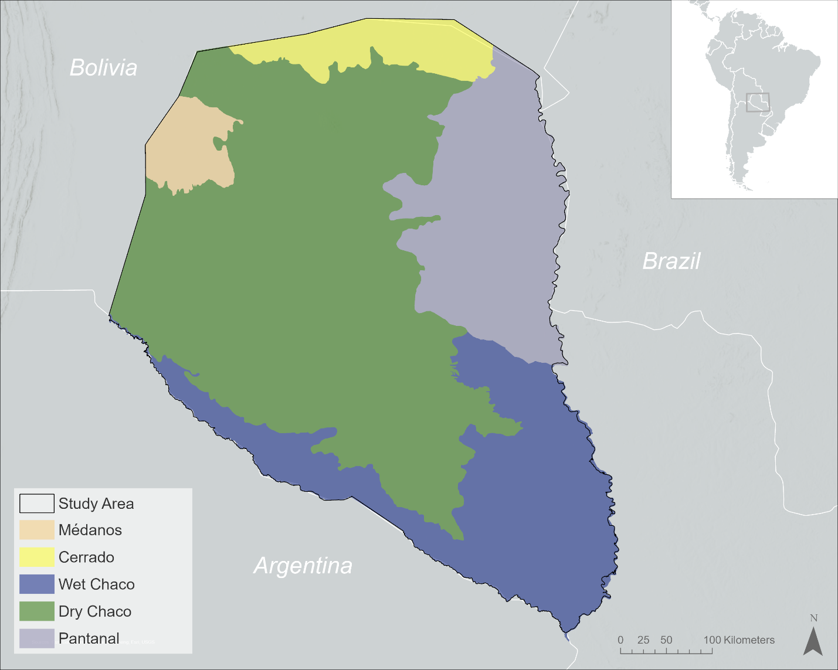
Figure 6. Paraguayan Chaco sub-ecoregions.

Climate and Fire Seasonality
The Paraguayan Chaco has a continental climate that is described as semi-arid with a thermal amplitude that exceeds 50 C and pronounced dry seasons (May through September). The wet season has an average precipitation between 400 and 800 mm/year in the north and northeast, and 1300-1400 mm/year in the east and southeast along the Paraguay river. The mean temperature oscillates between 13°C and 34°C, with the warmest zones concentrating on the northeast (Vidal-Riveros, Reyes, et al. 2024; Gill et al. 2020).

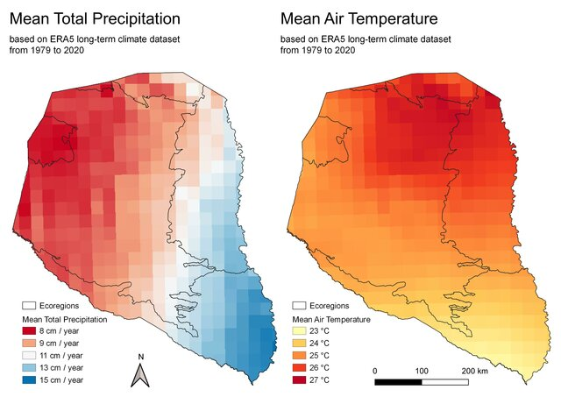
Figure 7. Mean Total Precipitation and Mean Air Temperature (Kacic 2021).
This regional fire seasonality varies spatially across the ecoregions. The dry Chaco presents a unimodal seasonality with fires concentrating more in the winter-spring seasons, while the wet Chaco shows a bimodal seasonality, with occurrence in summer-autumn and winter-spring seasons (San Martín et al. 2023). This seasonality is also linked with anthropogenic influence, as fire is used as a deforestation and agricultural management tool to clear land, promote grass growth, and facilitate slash-and-burn practices. These fires frequently escape into neighboring forests and shrublands, impacting biodiversity and ecosystem services (San Martín et al. 2023; Magliocca et al. 2022).

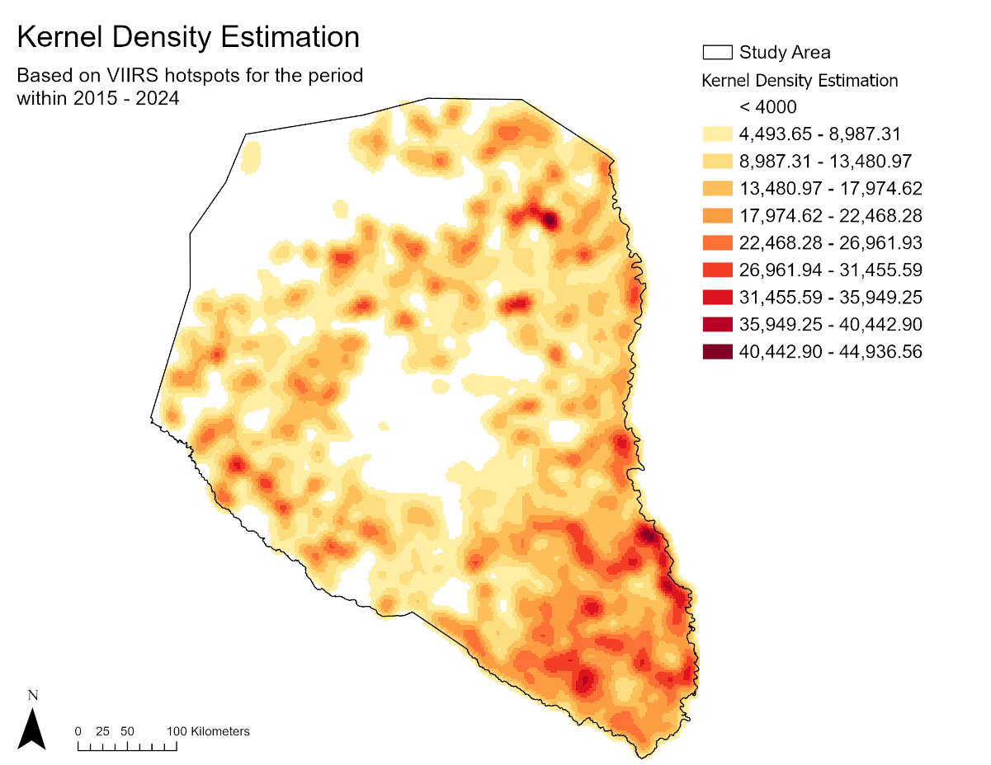
Figure 8. Spatial distribution of fire activity in the Paraguayan Chaco, 2015–2024. Kernel density estimation based on VIIRS active fire hotspots. Higher density (red) indicates areas of concentrated fire occurrence; lower density (yellow) indicates areas with sparse fire activity.

Land Use and Fire Regime
The Paraguayan Chaco’s vegetation is directly influenced by the precipitation regime gradient, with shrublands of different densities found in regions receiving less than 800 mm/year and dense woodlands occurring in areas with precipitation between 800 and 1300 mm/year (Vidal-Riveros, Reyes, et al. 2024). This vegetation consists of hydrophilic forests, dry forests, flooded savannahs and shrublands, wetlands, and agricultural fields (Gill et al. 2020).

This landscape has been under mounting pressure in recent decades, becoming a global hotspot for deforestation, with over 35% of woodland converted to agriculture since 1980 (Baumann et al. 2026). Between 2000 and 2023, extensive forest clearing for soybean cultivation and cattle ranching created a fragmented landscape mosaic dominated by pasture, cropland, and remnant forest patches (Figure 7). These rapid changes in land use are linked to fire, as fire is a tool for both clearing and management. Additionally, as a consequence of the rapid agriculture and livestock production expansion, the remaining forests are highly fragmented and degraded, becoming more susceptible to fires and disturbances (Vidal-Riveros, Reyes, et al. 2024).
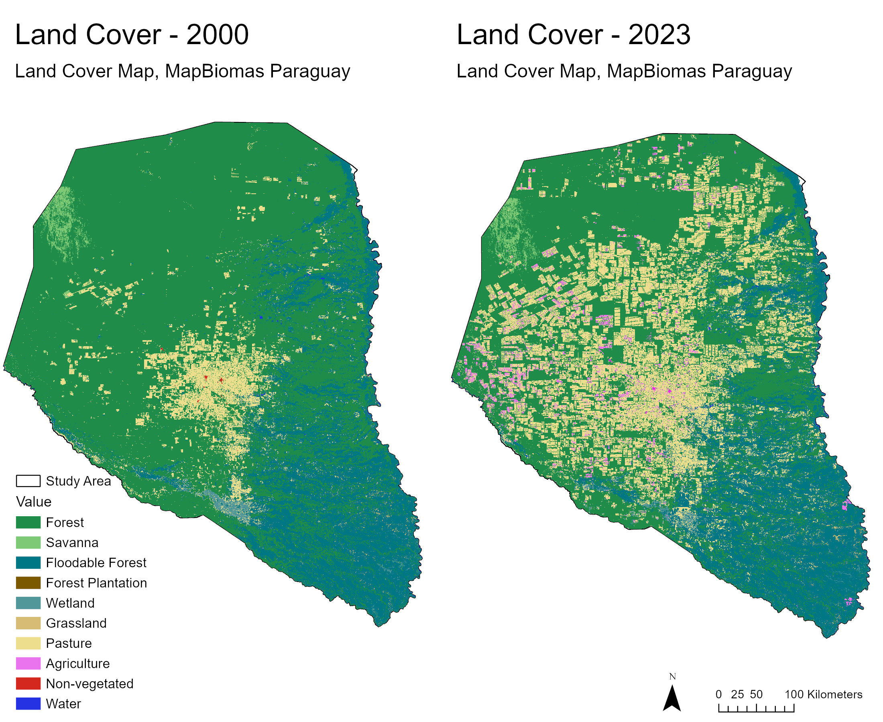
Figure 9. Land cover change in the Paraguayan Chaco, 2000–2023. (Left) Predominantly intact forest cover in 2000, with limited agricultural clearings. (Right) Extensive deforestation and agricultural expansion by 2023, particularly in the central and northern regions. Pasture (tan) and agriculture (pink) have replaced large areas of forest (dark green). Data source: MapBiomas Paraguay Project, Collection 9 (2026).

High-Value Assets at Risk
The Paraguayan Chaco houses a population of approximately 240,000, representing only 3% of Paraguay's total population. This population includes 14 distinct indigenous peoples, one of which lives in voluntary isolation—estimated at around 50 individuals living in small groups (Gill et al. 2020). These communities experience pressures from livestock and agricultural frontier expansion, both through direct forest loss and forest degradation, often related to fire events (Vallejos et al. 2020).

The Paraguayan Chaco is a biodiversity hotspot with high endemism and serves as a critical biological corridor for wide-ranging faunal species (Gill et al. 2020). Approximately 24.7% of the Paraguayan Chaco is under some form of legal conservation status, with 8.6% classified under IUCN protected area categories (Gill et al. 2020). The region also contains 15 Important Bird and Biodiversity Areas (IBAs) recognized for their avian conservation value. These protected areas and indigenous territories are increasingly threatened by agricultural expansion and recurrent fire events (Figure 7).

Critical infrastructure includes the Trans-Chaco Highway (Ruta 9), which connects Asunción to Bolivia and serves as the primary economic artery for the region, along with electrical transmission lines and agricultural facilities supporting ranching and soybean production (Caldas et al. 2015). These assets are vulnerable to fire damage due to the region's limited firefighting capacity and vast, sparsely populated terrain.

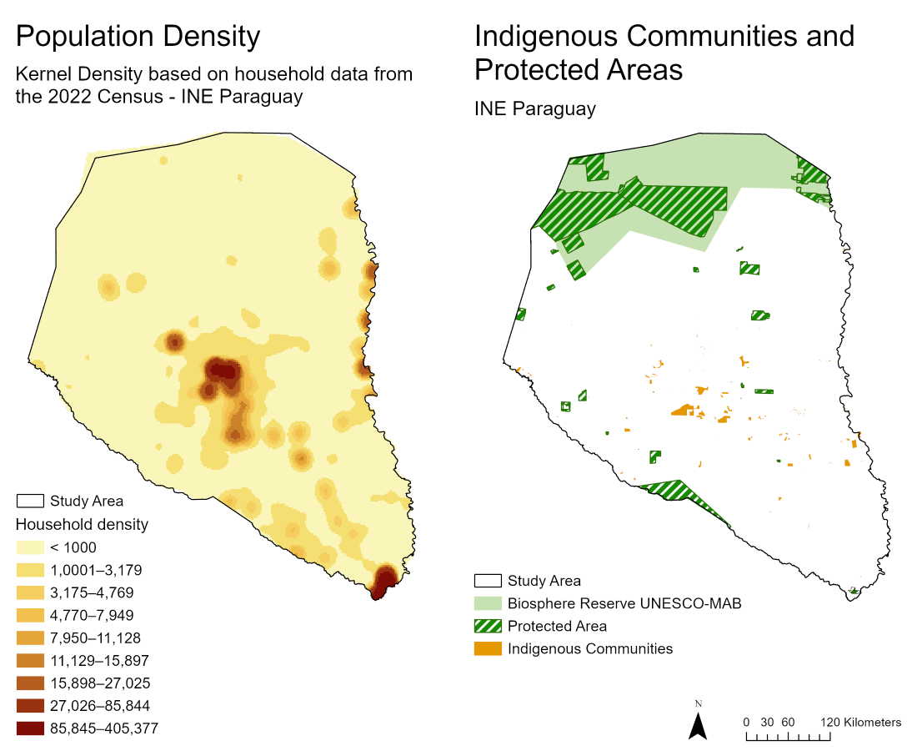
Figure 10. Spatial distribution of high-value assets in the Paraguayan Chaco. (Left) Population density derived from household data (INE Paraguay 2022 Census). (Right) Indigenous community lands and protected areas (IUCN categories and UNESCO-MAB Biosphere Reserve).

DATA
This study integrates data from multiple sources to support fire occurrence modeling, driver attribution analysis, land use conversion analysis, fire regime characterization, and risk assessment. All datasets were accessed and processed using Google Earth Engine (GEE) and Python-based geospatial libraries. Figure 10 illustrates the data flow and integration across the modeling framework. Table 1 summarizes the complete dataset inventory.

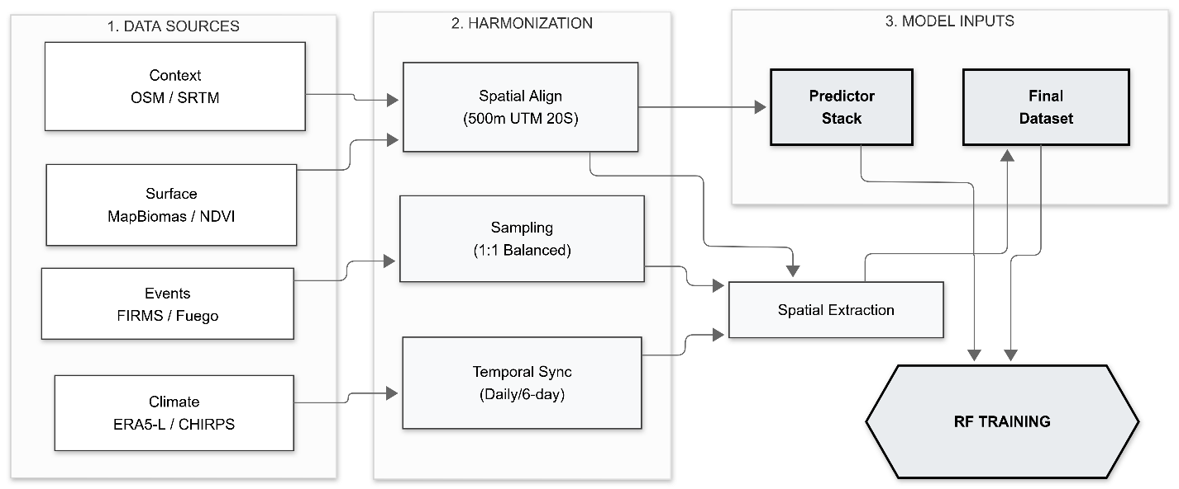
Figure 11. Data processing workflow.

Fire Occurrence and Burned Area Data
Fire data were obtained from two complementary sources to characterize both fire occurrence and fire extent. Active fire hotspot data from MODIS Collection 6.1 (Wan et al. 2015) and VIIRS (2012-2026) were accessed through NASA's Fire Information for Resource Management System (FIRMS). These point-based thermal anomaly detections provide daily fire occurrence at approximately 500m spatial resolution (MODIS) and 375m resolution (VIIRS). These data were used for Random Forest model training and validation, fire frequency analysis, and fire regime characterization.

Burned area perimeters were obtained from MapBiomas Fuego Collection 3 for Paraguay, which provides monthly and annual fire scar polygons derived from Landsat imagery at 30m spatial resolution for 1999-2024. These data were used to calculate fire size distributions, analyze seasonal burned area patterns, and estimate fire recurrence intervals. The combination of hotspot occurrence (FIRMS) and burned area extent (MapBiomas Fuego) provides complementary information on fire frequency versus fire magnitude across the 26-year study period (2000-2026).

Climatic Variables
Climatic predictor variables for the Random Forest model were obtained from ERA5-Land reanalysis and CHIRPS datasets at varying temporal resolutions and aggregated to represent conditions in the 6 days preceding each fire occurrence:

Precipitation: Daily precipitation data from CHIRPS (Climate Hazards Group InfraRed Precipitation with Station data) at 0.05° (~5.5 km) spatial resolution were used to calculate 6-day cumulative precipitation prior to fire occurrence. CHIRPS integrates satellite imagery with in-situ station data, providing reliable precipitation estimates for South America (Funk et al. 2015).

Air Temperature: Hourly 2-meter air temperature from ERA5-Land reanalysis at 0.1° (~9 km) spatial resolution (Muñoz-Sabater et al. 2021) was aggregated to 6-day mean temperature for each observation point. ERA5-Land provides improved spatial resolution compared to ERA5 through downscaling and enhanced representation of land surface processes.

Wind Speed: Scalar wind speed was calculated from ERA5-Land hourly U and V wind components at 10m height (0.1° resolution) using the Pythagorean formula: Ws = √(U² + V²). Six-day mean wind speed was calculated for each observation point to represent wind conditions influencing fire spread potential and fuel moisture.

Relative Humidity: Relative humidity was calculated from ERA5-Land 2-meter temperature and dewpoint temperature using the Magnus formula for saturation vapor pressure. Six-day mean relative humidity provides a measure of atmospheric moisture content and fuel dryness, a critical determinant of fire occurrence.

Evaporation: Total evaporation from ERA5-Land at 0.1° spatial resolution was aggregated to 6-day totals as a measure of atmospheric moisture demand and drought conditions. Evaporation serves as a proxy for potential evapotranspiration and cumulative water deficit.

Land Surface Temperature: Daily land surface temperature from MODIS MOD11A1 Collection 6.1 at 1km spatial resolution (Wan et al. 2015) was used to calculate 6-day mean LST, representing surface heating conditions and thermal stress on vegetation independent of air temperature measurements.

All climatic variables from ERA5-Land (hourly data) were temporally averaged over 6-day windows preceding each observation date, while CHIRPS daily precipitation was summed over the same window. Extraction was performed at observation point locations using bilinear interpolation for continuous variables.

Vegetation Indices
NDVI (Normalized Difference Vegetation Index): Monthly NDVI composites from Landsat Collection 2 Tier 1 Level 2 at 30m spatial resolution (USGS 2020) were used to characterize vegetation greenness and fuel availability. NDVI values were extracted for the month corresponding to each observation date.

Land Cover and Land Use Change Data
Annual Land Cover: MapBiomas Paraguay Collection 9 provides annual land cover classifications at 30m spatial resolution for 1985-2023 using Landsat time series imagery (MapBiomas 2024). The classification system includes detailed land cover classes aggregated into major categories for this analysis: forest (dense forest, open forest), savanna, grassland, pasture, agriculture (annual crops, perennial crops), water, and other. Annual land cover data were used as a categorical predictor in the Random Forest model (resampled to 500m using nearest-neighbor) and for identifying land use conversion zones.

Land Use Conversion Analysis: Time series of MapBiomas annual land cover (2000-2023) were analyzed to identify pixels that transitioned from natural vegetation (forest, savanna, grassland) to agricultural land uses (pasture, cropland). Conversion events were identified at the pixel level (30m resolution) and conversion zones were classified into temporal windows relative to the year of transition: pre-conversion (≥5 years before transition), active conversion (year of transition ±1 year), and post-conversion (≥3 years after transition). This temporal stratification enables analysis of fire regime changes during and after land use conversion.

Topographic Variables
Elevation, Slope, and Aspect: Topographic variables were derived from the Shuttle Radar Topography Mission (SRTM) 90m Digital Elevation Model accessed through Google Earth Engine (Farr et al. 2007). Slope (in degrees) and aspect (in degrees azimuth from north) were calculated using standard terrain analysis algorithms implemented in GEE. Elevation influences vegetation composition and fire regimes through moisture availability gradients. Slope affects fire spread rates through wind-topography interactions and fuel alignment. Aspect influences solar radiation exposure, affecting fuel moisture and ignition probability. These variables were extracted at observation point locations to characterize topographic influences on fire occurrence.

Anthropogenic Variables
Distance to Roads: Euclidean distance to the nearest road was calculated from the Paraguayan Statistical Office (INE) road network data for Paraguay. Roads were rasterized at 30m resolution and distance surfaces were generated using ArcGIS Pro Euclidean Distance tool. Distance values were extracted at observation point locations to represent accessibility and human ignition potential, as road proximity correlates strongly with anthropogenic fire occurrence in the Chaco region.

Distance to Water Bodies: Euclidean distance to permanent and seasonal water bodies was calculated from OpenStreetMap hydrography data for Paraguay. Water bodies (rivers, lakes, reservoirs) were rasterized at 30m resolution and distance surfaces were generated to represent proximity to water resources, which influences settlement patterns and agricultural activities.

Protected Areas and Forest Data
Protected Areas: Protected area boundaries were obtained from the IUCN World Database on Protected Areas (WDPA) and Paraguay's Sistema Nacional de Áreas Protegidas (SINASIP). These include national parks (including Defensores del Chaco National Park, the largest protected area in Paraguay), UNESCO-MAB Biosphere Reserves (Chaco Biosphere Reserve), and Important Bird and Biodiversity Areas (IBAs) designated by BirdLife International. Protected area polygons were rasterized to 500m resolution for exposure and vulnerability analysis.

Indigenous Territories: Indigenous community land boundaries were obtained from Paraguay's Instituto Nacional del Indígena (INDI) and the National Statistics Institute (INE) 2022 Census indigenous community registry. The Paraguayan Chaco is home to 14 distinct indigenous peoples, including one group living in voluntary isolation. Indigenous territory boundaries were used to assess fire exposure and vulnerability for forest-dependent communities.

Forest Integrity and Fragmentation: Forest fragmentation and integrity metrics were derived from MapBiomas land cover time series (2000-2023) at 30m resolution. Metrics include forest edge density (edge length per unit area), forest patch size, distance to forest edge, and time since forest disturbance (years since pixel transitioned from forest to non-forest). These metrics characterize forest vulnerability to fire based on fragmentation state and recent disturbance history.

Data Processing and Preparation
All spatial data were standardized to a common coordinate reference system (WGS84 / UTM Zone 20S, EPSG:32720) for geometric consistency across datasets. Predictor variables from image collections (climate, vegetation) were extracted at fire occurrence point locations and temporally matched non-fire background points using custom Google Earth Engine workflows implemented in Python.

Temporal Aggregation: Climatic variables at sub-daily temporal resolution (ERA5-Land hourly data) were aggregated to daily means, then averaged over 6-day windows preceding each observation date. CHIRPS daily precipitation was summed over 6-day windows. Monthly NDVI composites were matched to observation months. Annual land cover was matched to observation years. This temporal aggregation captures recent weather conditions influencing fuel moisture and ignition probability while maintaining computational efficiency.

Spatial Resampling: Variables at resolutions finer than 500m (Landsat NDVI at 30m, MapBiomas land cover at 30m, distance rasters at 30m) were extracted at point locations without resampling to preserve fine-scale spatial variability. Variables at resolutions coarser than 500m (ERA5-Land at ~9km, CHIRPS at ~5.5km) were extracted using bilinear interpolation. Categorical variables (land cover, degree of urbanization) were extracted using nearest-neighbor sampling to preserve class labels.

Background Point Sampling: For each year in the study period (2000-2026), 10,000 non-fire background points were randomly sampled from the Paraguayan Chaco study area with random dates distributed uniformly within each calendar year. This balanced sampling approach addresses class imbalance in fire presence-absence data and provides negative training examples for Random Forest classification. Background points were constrained to land areas (excluding water bodies) and sampled proportionally to ecoregion area.

Computational Workflow: All data extraction and processing workflows were implemented in Python using the Google Earth Engine Python API (geemap v0.20.0, earthengine-api v0.1.350), GeoPandas (v0.12.2), and Rasterio (v1.3.6) libraries. Extraction workflows were automated using custom functions and batched (2,000-4,000 points per batch) to comply with Google Earth Engine computational and memory limits. Processing was parallelized across multiple GEE tasks to reduce total extraction time. All workflows are documented in Jupyter notebooks and Python scripts archived with this research.

Summary

Table 1. Summary of datasets used in the fire occurrence modeling and risk assessment framework.
Dataset | Source | Format | Spatial Resolution | Temporal Coverage | Model Component
MODIS Active Fire Hotspots | NASA FIRMS (MCD14DL) | Vector (points) | ~500 m | 2000–2011 | RF training/validation, fire frequency
VIIRS Active Fire Hotspots | NASA FIRMS (VNP14IMGTDL) | Vector (points) | ~375 m | 2012–2026 | RF training/validation, fire frequency
MapBiomas Fuego Burned Area | MapBiomas Fuego Collection 3 | Raster | 30 m | 1999–2024 | Fire size, seasonality, recurrence
Precipitation | CHIRPS Daily v2.0 | Raster | 0.05° (~5.5 km) | 2000–2026 | RF predictor
Air Temperature | ERA5-Land Hourly | Raster | 0.1° (~9 km) | 2000–2025 | RF predictor
Wind Speed | ERA5-Land Hourly (U/V components) | Raster | 0.1° (~9 km) | 2000–2025 | RF predictor
Relative Humidity | ERA5-Land Hourly (calculated) | Raster | 0.1° (~9 km) | 2000–2025 | RF predictor
Evaporation | ERA5-Land Hourly | Raster | 0.1° (~9 km) | 2000–2025 | RF predictor
Land Surface Temperature | MODIS MOD11A1 v6.1 | Raster | 1 km | 2000–2026 | RF predictor
NDVI | Landsat Collection 2 Tier 1 L2 32-Day | Raster | 30 m | 2000–2026 | RF predictor
Land Cover | MapBiomas Paraguay Collection 9 | Raster | 30 m | 2000–2023 | RF predictor, conversion analysis, vulnerability
Elevation | SRTM 90m DEM v4 | Raster | 90 m | Static | RF predictor
Slope | Derived from SRTM | Raster | 90 m | Static | RF predictor
Aspect | Derived from SRTM | Raster | 90 m | Static | RF predictor
Distance to Roads | INE | Raster (derived) | 30 m | 2024 | RF predictor
Distance to Water Bodies | INE | Raster (derived) | 30 m | 2024 | RF predictor
Protected Areas | IUCN WDPA, SNAP Paraguay | Vector (polygons) | N/A | 2024 | Vulnerability assessment
Indigenous Territories | INE Paraguay, INDI | Vector (polygons) | N/A | 2024 | Vulnerability assessment

METHODS
The methodological framework is divided into three primary phases: data harmonization, predictive modeling, and integrated risk synthesis, as visualized in Figure 10.

Fire Ignition Probability Modeling (Random Forest)

Predictor Variable Selection
Fourteen variables recognized as key determinants for fire occurrence were selected as fire predictors. These variables were mentioned as related to fire behavior in the Paraguayan Chaco (Section 2.4.1). To select them, temporal and spatial scale and resolution was considered. Datasets were required to provide full coverage of the Paraguayan Chaco at a spatial resolution no coarser than 1 km (targeting a 500m common grid) and spanning the 2000–2025 temporal window.

To ensure model parsimony and prevent the 'smearing' of feature importance during the interpretability phase, candidate variables will be screened using a Spearman Rank Correlation matrix through Python’s Scikit-learn and Pandas libraries. In instances of high collinearity (ρ>0.8), the variable with the strongest theoretical link to fire ignition will be retained.

Vector datasets used as proxies for human activities such as roads and settlements will be rasterized by computing Euclidean distance metrics. The data will be extracted at the point location for training sets, and aggregation calculations will be run for the calibration as this will perform over a grid cell array and not as point vector.

Finally, while the Random Forest model is trained on data extracted at discrete point locations (Presence/Absence), the final calibration and prediction phases will be executed over a standardized 500m grid array. This ensures that the resulting ignition probability surface is spatially continuous and aligned with the resolution of the primary environmental drivers.

Model Training and Validation
The fire ignition probability was modeled using a Random Forest (RF) Classifier, implemented in Python using RandomForestClassifier from the Scikit-learn library. Random Forest was selected for its robustness and intuitive algorithm, requiring less hyperparameter tuning than more complex methods.

The dataset has approximately 500,000 fire hotspots (presence data) and an equal number of non-fire locations (absence data) for the 2000–2025 period. It was partitioned using a stratified 80-20 split. In this framework, 80% of the observations were dedicated to model training, while the remaining 20% were reserved as an independent hold-out set for cross-validation and performance testing.

To generate the absence (non-fire) data, a custom sampling function was developed using GeoPandas. This function executed a spatiotemporal random sampling strategy, generating 10,000 points per year across the study area. This balanced approach maintains a roughly 1:1 ratio between presence and absence and was utilized to prevent the classification bias that often occurs in imbalanced wildfire datasets.

Model optimization was achieved through Hyperparameter Tuning using a Grid Search cross-validation approach. Specifically, the model was tuned for:

- Number of trees (n_estimators): To ensure forest stability and prevent over-fitting.
- Maximum depth (max_depth): To control the complexity of the individual decision trees.
- Minimum samples per split: To define the minimum number of data points required to form a new branch.
- Maximum features: To determine the subset of predictors considered at each node, promoting diversity among the trees in the ensemble.

Model Performance Evaluation
The predictive accuracy and discriminative power of the Random Forest model were assessed using a suite of standard machine learning metrics. The primary metric was Area Under the Curve (AUC), calculated for the Receiver Operator Characteristic (ROC) curve to be able to assess the predictive power of the model. AUC provides a quantification of the model’s ability to classify the dataset correctly, with values between 0 to 1, where 0.8—0.9 is excellent, and 0.9—1.0 outstanding.

Additionally, Cohen's Kappa coefficient was calculated to assess classification accuracy
while accounting for chance agreement, particularly important given the balanced but
binary nature of the fire presence-absence dataset. Kappa values >0.6 indicate substantial
agreement, while values >0.8 indicate excellent model performance.

To further evaluate the model’s reliability, a Confusion Matrix was generated using the 20% independent validation hold-out set. This allowed for the quantification of omission errors (False Negatives), where the model fails to identify a fire ignition, and commission errors (False Positives), where the model predicts an ignition in a stable area.

Finally, Random Forest's built-in feature importance (mean decrease in impurity) was
calculated to provide an initial ranking of predictor variable contributions, serving as
a baseline for comparison with the more rigorous SHAP-based driver attribution analysis
(Section 5.4).

Fire Probability Surface Generation
Once the Random Forest model was finalized and validated, it was deployed to generate a continuous spatial estimate of fire risk across the study area. This process involved transitioning from point-based observations to a wall-to-wall spatial prediction over a standardized 500-meter grid array covering the entire Paraguayan Chaco.

For every pixel in the study area, the values of all 14 predictor variables were extracted from the harmonized raster stack and fed into the trained Random Forest classifier. Rather than producing a binary (0 or 1) classification, the model utilized the predict_proba function to calculate a continuous probability score ranging from 0.0 to 1.0. This value represents the statistical likelihood that a specific 500-meter cell possesses the environmental and anthropogenic characteristics associated with fire ignition. The resulting Fire Probability Surface was exported as a high-resolution GeoTIFF, providing a foundational layer for the subsequent risk assessment and driver attribution phases.

Land Use Conversion Analysis

Identifying Conversion Zones
The analysis is based on MapBiomas Paraguay Collection 9 land cover classifications, with 30 meters of resolution. The changes will be tracked at the pixel level, with each pixel tracked annually to identify land cover transitions. The land cover class conversion of interest will be natural vegetation (forest formations, savannas, grasslands) to agricultural land uses (pasture, cropland).

The land cover time series analysis will be carried out through the rasterio library in Python. For each pixel, the land cover class will be compared from year t to year t-1 to detect transitions. The year of transition will be recorded for each pixel, and a binary mask of converted (1) vs stable (0) will be generated. The year the transition occurred will also be stored, using the first permanent conversion as reference for pixels with multiple transitions.

Temporal Window Classification
The transitions will be classified within a temporal windows following literature on the subject, indicating fire regime responses to land use having a lag and evolving over multiple years. Each pixel-year observation is classified into one of four temporal categories relative to its conversion year, as described in Table 2.

Table 2. Temporal window classification keys.
Temporal Category | Conversion years
Pre-conversion baseline | ≥5 years before conversion year (stable natural vegetation, represents baseline fire regime)
Active conversion | Conversion year ±1 year (3-year window capturing clearing period and immediate aftermath)
Post-conversion stabilized | ≥3 years after conversion (agricultural land management established)
Never converted | Pixels with stable land cover throughout 2000-2023 (control category)

Window thresholds (5 years pre, 3 years post) are based on fire ecology literature showing regime shifts occur within 2-5 years of disturbance (Baumann et al. 2026).

For each pixel with a recorded conversion year, the temporal offset was calculated (observation year - conversion year). Classification rules were applied to assign a temporal category, resulting in every pixel-year observation (2000-2023) labeled with both land cover type and conversion temporal window.

This will enable stratified fire regime analysis, comparing fire frequency, size, and seasonality across pre/active/post-conversion periods.

Spatial Stratification by Conversion Intensity
Individual pixel conversions will be aggregated to landscape scale using a 5 km × 5 km
moving window analysis to calculate:

- Percent area converted (cumulative 2000-2023)
- Conversion rate (hectares per year, captures velocity of agricultural expansion)
- Conversion density (number of conversion events per unit area)

This stratified output was used to create an intensity zone layer classified according to the intensity classes described in Table 3.

Table 3. Spatial conversion intensity classes.
Intensity Class | Percentage of converted area
High Intensity | > 40
Moderate Intensity | 20 – 40
Low Intensity | 5 – 20
Unconverted | 0 – 5

These conversion zones and temporal windows provide the spatial and temporal stratification framework for fire regime characterization (Section 5.3) and enable assessment of how fire dynamics change during and after agricultural land use conversion.

Fire Regime Characterization

Fire Frequency Calculation
Fire frequency was calculated using FIRMS MODIS (2000-2011) and VIIRS (2012-2026) active fire hotspot data. The primary metric was fires per pixel per year, with fire aggregated to fires per 100 km² per year for landscape-scale reporting. The fires were also aggregated to 500m grid cells, Paraguayan Chaco ecoregions, conversion zones, protected areas, and indigenous territories. Fires were also aggregated per year, for trend analysis.

Fire frequency was calculated separately for:
- Land cover types: forest, savanna, grassland, pasture, cropland (from MapBiomas annual classifications)
- Conversion temporal windows: pre-conversion (≥5 years before), active conversion (±1 year), post-conversion (≥3 years after), never converted
- Conversion intensity zones: high, moderate, low, unconverted (from Section 5.2.3)

The calculations were done in Python through the rasterstats library.

The Mann-Kendall trend test was applied to annual fire frequency time series (2000-2026)
for each land cover type and conversion zone to detect statistically significant monotonic
trends (increasing or decreasing fire activity over time) at α = 0.05 significance level.

Fire Size Distribution Analysis
The fire size analysis was based on the vectorized MapBiomas Fuego burned area product (1999-2024) at 30m resolution. Each fire event (individual polygon) represents a discrete fire scar with defined boundaries. Area for each individual polygon was created using GeoPandas.

Fire size distributions were calculated separately for:
- Land cover types (forest fires, savanna fires, agricultural fires, etc.)
- Conversion temporal windows (pre/active/post-conversion)
- Conversion intensity zones
- Ecoregions

Fire size characteristics and distribution were analyzed considering fire size class through fire size, analyzing also fire size frequency and distribution. Kolmogorov-Smirnov, two sample tests were used to compare fire size distributions between categories (e.g., pre-conversion vs. post-conversion, forest fires vs. agricultural fires), testing whether distributions differed significantly.

Seasonal Pattern Analysis
For the seasonal pattern analysis, monthly fire occurrence counts from FIRMS data (2000-2026) were aggregated across entire study period. The proportion of annual fires occurring each month was calculated to identify peak fire months, stratified by land cover type and conversion status to compare natural fire season and agricultural burning season as well as pre and post conversion patterns.

Additionally, monthly burned area totals from MapBiomas Fuego were aggregated to show seasonal patterns in fire extent. Fire occurrence was compared with burned area seasonality to explore the patterns of fires in peak occurrence months.

Circular statistics (circular mean and concentration parameter) were calculated using Python's scipy.stats library to quantify fire seasonality and assess temporal clustering around peak fire months. Mean fire dates were compared between early (2000-2010) and recent (2015-2025) periods to assess whether fire seasonality has shifted as land cover change has intensified in the Paraguayan Chaco. Watson’s U² test was used for comparing circular distributions between time periods or land use types.

Recurrence Interval Estimation
Fire recurrence interval (return interval) was analyzed by measuring the mean time in years between successive fires at the same location. This metric provides insight into patterns of fire pressure, often associated with fire management and use practices.

MapBiomas Fuego annual burned area rasters (1999-2024) were used to track repeated burning at pixel level, for each 30m pixel, all years in which it burned (binary time series: 1 = burned, 0 = not burned) were identified. The total number of fire events across the study period, years between successive burns and the mean return interval (study period length) / (number of fires)) for each pixel.

This recurrence interval layer was then compared across land use type, conversion status and conversion intensity zones. These fire regime characteristics—frequency, size, seasonality, and recurrence prove the empirical foundation for driver attribution analysis (Section 5.4).

Driver Attribution Analysis

SHAP Value Calculation
Random Forest provides accurate fire probability predictions but operates as a "black box", thus becoming difficult to understand which variables drive predictions and how. Additionally, traditional RF feature importance (mean decrease in impurity) provides global rankings but lacks individual prediction explanations, direction of effect, and consistency across different subsets of data. SHAP (SHapley Additive exPlanations) addresses these limitations by providing theoretically grounded variable attribution based on cooperative game theory (Lundberg & Lee 2017). SHAP values quantify each predictor's contribution to moving the model prediction away from the baseline (average prediction across all observations).

The SHAP framework is derived from Shapley values in game theory: fairly distribute a "payout" (prediction) among "players" (predictor variables) based on their marginal contributions. Key properties ensuring interpretability:
- Local accuracy: Sum of SHAP values for all variables equals the difference between individual prediction and baseline prediction
- Consistency: If a variable contributes more to one model than another, its SHAP value is higher
- Missingness: Variables not used in prediction have zero SHAP value

For tree-based models (Random Forest), TreeSHAP algorithm (Lundberg et al. 2020) provides efficient exact calculation by exploiting tree structure. SHAP values are also additive: they can sum across variable groups (e.g., all climate variables, all anthropogenic variables) to compare driver categories.

SHAP calculations performed on trained Random Forest model (Section 5.1) using Python shap library. Full-dataset SHAP calculation was computationally expensive (~500,000 observations × 14 variables), therefore a stratified sampling approach was proposed to balance computational requirements:
- Sample 50,000 observations (10% of full dataset) stratified by:
  - Fire probability quintiles (ensure coverage of low/medium/high probability predictions)
  - Land cover types (proportional representation of forest, savanna, pasture, cropland)
  - Ecoregions (Dry Chaco, Wet Chaco, Pantanal)
  - Conversion status (pre/active/post-conversion, never converted)

Global Feature Importance Analysis
Global feature importance was derived by aggregating SHAP values across all sampled observations to identify which variables contribute most to fire occurrence predictions across the entire study area. The primary metric used was the mean absolute SHAP value for each predictor variable. Taking the absolute value removes the directionality of effects (positive or negative contributions), focusing instead on the magnitude of each variable's influence regardless of whether it increases or decreases fire probability. The mean absolute SHAP value across all observations represents the average importance of each variable in the model's predictions.

Variables were ranked by mean absolute SHAP value to identify the top fire drivers in the Paraguayan Chaco. This ranking provides a robust measure of variable importance that addresses limitations of traditional Random Forest feature importance metrics, which can be biased toward high-cardinality or continuous variables and do not account for variable interactions.

Two primary visualizations were generated to communicate SHAP-based feature importance. The SHAP summary plot (beeswarm plot) displays the distribution of SHAP values for each variable, with variables ranked on the y-axis by mean absolute SHAP value, the x-axis showing individual SHAP value contributions, and point colors representing feature values from low (blue) to high (red). Complementing this, a SHAP bar plot provides a simpler ranking by mean absolute SHAP value, facilitating clear communication of the top drivers.

The SHAP global importance ranking was compared with the Random Forest's built-in feature importance (mean decrease in impurity calculated in Section 5.1.3) to validate consistency between methods. A mixed importance profile would reveal the interplay between climatic and anthropogenic factors in shaping fire patterns across the Paraguayan Chaco.

Spatial Patterns of Driver Dominance
While global feature importance (Section 5.4.2) identifies the overall top fire drivers, it masks spatial heterogeneity in what controls fire occurrence across different regions of the Paraguayan Chaco. Fire drivers are expected to vary geographically based on land use intensity and remoteness: intact forest areas in protected zones likely experience climate-dominated fire regimes where precipitation and temperature control fuel moisture and ignition conditions, while agricultural frontier zones are expected to show human-dominated regimes driven by land clearing, pasture burning, and proximity to roads.

To characterize spatial patterns of driver dominance, SHAP values were calculated for a representative spatial sample of pixels across the Paraguayan Chaco. For each sampled pixel, SHAP values for all 14 predictor variables were calculated using the trained Random Forest model and TreeSHAP algorithm.

Predictor variables were grouped into driver categories by summing their absolute SHAP value contributions:
- Climate drivers: Precipitation + Temperature + Wind speed + Relative humidity + Evaporation + Land surface temperature
- Anthropogenic drivers: Land cover + Distance to roads + Distance to settlements
- Vegetation drivers: NDVI (analyzed separately given its dual nature—influenced by both climate and management)
- Topographic drivers: Elevation + Slope + Aspect

For each sampled pixel, the relative contribution of climate versus anthropogenic drivers was calculated as the proportion of total SHAP magnitude attributable to each category. Pixels were then classified using a dominance threshold: if climate drivers accounted for more than 60% of the combined climate and anthropogenic SHAP contributions, the pixel was classified as climate dominant. If anthropogenic drivers exceed 60%, it was classified as anthropogenic-dominant. Pixels falling between these thresholds (40-60% for either category) were classified as having mixed drivers. The 60% threshold was selected to identify clear dominance while acknowledging that fire occurrence typically involves multiple interacting factors; sensitivity analysis using alternative thresholds (50%, 65%, 70%) was conducted to assess the robustness of spatial patterns to classification criteria.

The resulting Driver Dominance Map was generated as a raster surface covering the Paraguayan Chaco, with climate-dominant zones displayed in blue, anthropogenic-dominant zones in red, and mixed-driver zones in yellow. This map was overlaid with conversion intensity zones (from Section 5.2.3), protected area boundaries, indigenous territory boundaries, and ecoregion classifications to assess spatial associations.

Zonal statistics were calculated to quantify driver dominance within different landscape categories. The percentage of each conversion intensity zone (high, moderate, low, unconverted) that was classified as climate-dominant, anthropogenic-dominant, or mixed was tabulated. Similarly, driver dominance distributions were calculated for protected areas, indigenous territories, and each ecoregion.

Ecosystem Vulnerability

High-Value Asset Classification
Natural forest, shrubland, and wetland formations in the Paraguayan Chaco represent a high-value ecosystem at risk. They provide critical ecosystem services and serve as source of resources to indigenous and rural populations. Given the rapid agricultural expansion in the Paraguayan Chaco, they face mounting pressure. To assess ecosystem vulnerability, intrinsic characteristics such as integrity and fragmentation state will be combined with exposure to fire threats.

The MapBiomas Paraguay Collection 9 product annual land cover classifications were used to identify forest, wetland, and shrubland pixels. A multi-year approach (2000—2023) was taken to exclude regenerating areas. Non-forest and agricultural lands were excluded.

Forest integrity was assessed using spatial pattern metrics derived from MapBiomas land cover time series (2000-2023). The metrics assessed were a) forest edge density, b) distance to forest edge, c) forest patch size, and d) time since forest disturbance.

Forest edge density: Edge length in meters per unit area in hectares was calculated using a moving window analysis of 500 x 500 meters. High edge density indicates fragmented forest with extensive forest-agriculture interface. The calculations were done with ArcGIS Pro.

Distance to forest edge: Euclidean distance in meters from each forest pixel to nearest forest edge. The output creates interior forest pixels (far from edge) vs. edge pixels (near boundary) classification, allowing for vulnerability to fire penetration, wind damage, altered microclimate to be assessed. The calculation was carried out in ArcGIS Pro creating a binary forest mask, calculating the Euclidean distance and transforming negative values for forest interior.

Forest patch size: Area (hectares) of contiguous forest patch containing each forest pixel. The output creates a classification of large forest blocks vs. small and isolated fragments. Small patches are assumed to have high edge-to-area ratio, less buffering capacity, and higher vulnerability.

Time since forest disturbance: Years since pixels last transitioned from forest to non-forest or experienced degradation. This metric assessed the recent disturbance and indicated reduced resilience and increased vulnerability to subsequent fire. For each forest pixel in 2023, through a Python custom function, searched backward through time series to find most recent year when pixel was non-forest. If always forested (2000-2023), then time since disturbance = 24+ years (stable, high integrity), else if deforested in 2018 but regenerated by 2023, then time since disturbance = 5 years (recent disturbance, lower integrity).

Finally, all metrics were combined into a normalized composite forest integrity index on a 0-1 scale, where higher means more intact. All inputs were normalized to a 0-1 range:
- Edge density: Invert and normalize (low edge density = high integrity)
- Distance to edge: Normalize (far from edge = high integrity)
- Patch size: Normalize with logarithmic transformation (large patches = high integrity)
- Time since disturbance: Normalize (long time = high integrity)

To simplify the approach, a simple average calculation was used for aggregation:

$$Forest integrity=\frac{edge density+distance to edge+size+disturbance interval}{4}$$

This equal-weight average was used given lack of empirical data to justify differential weighting.

Forest Exposure Metrics
As described in section 2.3.1, exposure refers to the proximity of an HVA to a hazard source. In the case of forests for this study, exposure was defined as spatial proximity to fire-prone areas and ignition sources. Three components are taken for fire exposure: a) fire probability surface from RF model, b) distance to agricultural conversion zones, and c) historical fire frequencies.

Fire probability from Random Forest model: The fire probability surface generated in Section 5.1.4 (continuous 0-1 probability at 500m resolution) was used, extracting the fire probability value for each forest pixel. High fire probability = high exposure (forest located in areas with environmental/anthropogenic conditions conducive to fire).

Distance to agricultural conversion zones: The conversion zone layer from Section 5.2.1 (pixels that transitioned from natural vegetation to agriculture 2000-2023) was used to calculate the Euclidean distance from each forest pixel to nearest conversion zone. Proximity to active agricultural expansion indicates exposure to clearing fires, assumed increased fire ignition sources, and edge effects from fragmentation. Distance metric were inverted and normalized: Exposure = 1 / (1 + distance) . Forests immediately adjacent to conversion (distance = 0) have an exposure value of 1.0, whereas forests 10 km from conversion have an exposure value of 1/(1+10) = 0.09 (low exposure).

Historical fire frequency: Fire frequency calculations from Section 5.3.1 (fires per pixel per year, 2000-2026) were used to extract historical fire frequency for each forest pixel (or for 500m grid cell containing forest pixel). High historical frequency indicates persistent fire exposure (recurring ignitions, favorable fire conditions, or fire-prone landscape context). The output was normalized to 0-1 scale based on distribution (e.g., min-max normalization or percentile-based scaling).

Finally, the three exposure components were combined into a single Forest Exposure Index with a 0-1 scale, higher meaning greater exposure. The aggregation approach followed a weighted average sum, with equal weights used to capture multiple exposure pathways without assuming multiplicative interactions. The resulting output was a forest pixel assigned exposure index 0-1.

Vulnerability Scoring
Forest vulnerability to fire was calculated by integrating forest integrity and exposure into the vulnerability framework. Vulnerable forests will have low integrity (fragmented, recently disturbed) and high exposure (fire-prone, near conversion zones). The vulnerability index follows this conceptual model:

- High integrity + Low exposure = Low vulnerability (resilient forests in low-risk areas)
- High integrity + High exposure = Moderate vulnerability (intact but threatened)
- Low integrity + Low exposure = Moderate vulnerability (degraded but not immediately threatened)
- Low integrity + High exposure = High vulnerability (degraded forests in fire-prone areas)

A geometric mean approach was chosen to calculate the vulnerability index:

$$Vulnerability= \sqrt{Exposure ×(1-Integrity)}$$

This approach balances multiplicative interaction with partial compensation and provides a less extreme output than the pure multiplicative approach.

The calculation was applied to all forest pixels across the Paraguayan Chaco region, resulting in a Forest Vulnerability Surface at 500 meters of resolution.

Table 4. Vulnerability classes.
Classification | Values
Low vulnerability | 0.0 – 0.25
Moderate vulnerability | 0.26 – 0.50
High vulnerability | 0.51 – 0.75
Very high vulnerability | 0.76 – 1.0

The results were validated using a post-hoc approach, comparing the vulnerability scores to actual fire occurrences between the study temporal window. Zonal statistics were calculated with the vulnerability surface on protected area boundaries, indigenous territories, driver dominance zones, and conversion intensity zones.

Forest vulnerability, combined with fire probability (Section 5.1.4), provides the foundation for integrated fire risk assessment, enabling spatial prioritization of conservation and fire management efforts across the Paraguayan Chaco.

Integrated Risk Assessment

Risk Map Generation
Fire risk is defined as the combination of hazard and vulnerability. The risk map was generated by integrating the Fire Probability surface from Section 5.1 and the Forest Vulnerability surface from Section 5.5. The model will output high risk areas where both high fire risk and high forest vulnerability occur:
- High fire probability + High vulnerability = High Risk (fires likely AND forests susceptible)
- High fire probability + Low vulnerability = Moderate Risk (fires likely but forests resilient)
- Low fire probability + High vulnerability = Moderate Risk (degraded forests but fires unlikely)
- Low fire probability + Low vulnerability = Low Risk (fires unlikely AND forests resilient)

The surface was calculated with a simple multiplicative overlay approach. This approach is sufficient given that both components must be present for maximum risk, and it is a common approach in risk assessment. The implementation was done through raster algebra, and the output has a 500-meter resolution, matching the RF model grid.

Once the model output was obtained, the continuous risk values were classified into discrete risk categories as described in Table 5.

Table 5. Risk classes.
Category | Values
Low Risk | 0.00 – 0.25
Moderate Risk | 0.26 – 0.50
High Risk | 0.51 – 0.75
Very High Risk | 0.76 – 1.00

Equal intervals were chosen to maintain consistency with vulnerability classification and facilitate comparison across maps. The outputs are a) Continuous Fire Risk raster (0 – 1 value, GeoTIFF format), b) Categorical Fire Risk map (4-class classification, color-coded for visualization), and c) Vector polygons of high and very high-risk zones (for overlay analysis and area calculations).

Overlay Analysis and Spatial Prioritization
With the final Fire Risk layer zonal statistics were calculated for each priority area:
- Protected Areas
- Indigenous Territories
- Ecoregions
- Conversion Intensity Zones
- Driver Dominance Zones

The integrated fire risk assessment provides a spatial framework for prioritizing fire management and conservation interventions across the Paraguayan Chaco. Results of the fire occurrence modeling, driver attribution analysis, fire regime characterization, and risk assessment are presented in Section 6.

RESULTS

Fire Ignition Model Performance

Fire Spread Model Calibration and Validation

Burn Probability Surfaces

Vulnerability Assessment Outputs

Integrated Risk Maps

Uncertainty Analysis

DISCUSSION

Model Performance and Validation

Spatial Patterns of Fire Risk

Implications for Fire Management

Limitations and Future Research

CONCLUSIONS

7. BIBLIOGRAPHY
Armenteras, Dolors, Tania Marisol González, and Javier Retana. 2013. “Forest Fragmentation and Edge Influence on Fire Occurrence and Intensity under Different Management Types in Amazon Forests.” Biological Conservation 159 (March): 73–79. https://doi.org/10.1016/j.biocon.2012.10.026.
Balch, Jennifer K., Daniel C. Nepstad, and Lisa M. Curran. 2009. “Pattern and Process: Fire-Initiated Grass Invasion at Amazon Transitional Forest Edges.” In Tropical Fire Ecology: Climate Change, Land Use, and Ecosystem Dynamics, edited by Mark A. Cochrane. Springer. https://doi.org/10.1007/978-3-540-77381-8_17.
Baumann, Matthias, Oswaldo Maillard, Ignacio Gasparri, Jamie Burton, Gregorio Gavier Pizarro, and Tobias Kuemmerle. 2026. “Fire Dynamics in the South American Chaco and Their Link to Agriculture and Drought.” Nature Sustainability, ahead of print, March 27. https://doi.org/10.1038/s41893-026-01793-z.
Bihari, Enikoe, Karen Dyson, Kayla Johnston, et al. 2025. “Modeling Seasonal Fire Probability in Thailand: A Machine Learning Approach Using Multiyear Remote Sensing Data.” Remote Sensing 17 (19): 3378. https://doi.org/10.3390/rs17193378.
Bowman, M. J. S., Jennifer Balch, Paulo Artaxo, and William Bond. 2009. “Fire in the Earth System.” Science 324 (5926): 481–84. https://doi.org/10.1126/science.1163886.
Chen, Shikun. 2021. “Interpretation of Multi-Label Classification Models Using Shapley Values.” arXiv:2104.10505. Preprint, arXiv, April 21. https://doi.org/10.48550/arXiv.2104.10505.
Chuvieco, Emilio, Inmaculada Aguado, Marta Yebra, et al. 2010. “Development of a Framework for Fire Risk Assessment Using Remote Sensing and Geographic Information System Technologies.” Ecological Modelling, Special Issue on Spatial and Temporal Patterns of Wildfires: Models, Theory, and Reality, vol. 221 (1): 46–58. https://doi.org/10.1016/j.ecolmodel.2008.11.017.
Cochrane, Mark A., and Kevin C. Ryan. 2009. “Fire and Fire Ecology: Concepts and Principles.” In: Cochrane, Mark A., Ed. Tropical Fire Ecology: Climate Change, Land Use, and Ecosystem Dynamics. Springer-Praxis Books in Environmental Sciences. Chichester, UK: Praxis Publishing, Ltd. p. 25-62., 25–62. https://doi.org/10.1007/978-3-540-77381-8_2.
Corona-Núñez, Rogelio O., and Julio E. Campo. 2023. “Climate and Socioeconomic Drivers of Biomass Burning and Carbon Emissions from Fires in Tropical Dry Forests: A Pantropical Analysis.” Global Change Biology 29 (4): 1062–79. https://doi.org/10.1111/gcb.16516.
Farr, Tom G., Paul A. Rosen, Edward Caro, et al. 2007. “The Shuttle Radar Topography Mission.” Reviews of Geophysics 45 (2). https://doi.org/10.1029/2005RG000183.
Ferro, A., I. Barberá, J. Foguet, T. Kitzberger, and E. Aráoz. 2026. “Why Are You Burning? The Interplay between Land Cover, Climatic Variability and Fire Activity in the Dry Forests of Argentina.” International Journal of Wildland Fire 35 (3): WF25126. https://doi.org/10.1071/WF25126.
Giglio, Louis, Luigi Boschetti, David P. Roy, Michael L. Humber, and Christopher O. Justice. 2018. “The Collection 6 MODIS Burned Area Mapping Algorithm and Product.” Remote Sensing of Environment 217 (November): 72–85. https://doi.org/10.1016/j.rse.2018.08.005.
Gill, EA, E. Da Ponte, KP Insfran, and LR Gonzalez. 2020. Atlas Del Chaco Paraguayo. Asunción, Paraguay. WWF (World Wildlife Fund), DLR (Agencia Aeroespacial Alemana).
Harrison, Sandy P., I. Colin Prentice, Keith J. Bloomfield, et al. 2021. “Understanding and Modelling Wildfire Regimes: An Ecological Perspective.” Environmental Research Letters 16 (12): 125008. https://doi.org/10.1088/1748-9326/ac39be.
Illarionova, Svetlana, Dmitrii Shadrin, Fedor Gubanov, et al. 2025. “Exploration of Geo-Spatial Data and Machine Learning Algorithms for Robust Wildfire Occurrence Prediction.” Scientific Reports 15 (1): 10712. https://doi.org/10.1038/s41598-025-94002-4.
Jasser, Marie Theresa, Isabella M. Radhuber, and Mirna Inturias. 2021. “Motley Territories in a Plurinational State: Forest Fires in the Bolivian Chiquitanía.” Third World Thematics: A TWQ Journal 6 (4–6): 179–99. https://doi.org/10.1080/23802014.2022.2146182.
Kacic, Patrick. 2021. “Forest Structure Analysis in the Paraguayan Chaco Based on Sentinel-1, Sentinel-2 and GEDI Data.”
Magliocca, Nicholas R., Ariane C. de Bremond, Evan A. Ellicott, et al. 2022. “Two of a Kind? Large-Scale Land Acquisitions and Commodity Frontier Expansion in Argentina’s Dry Chaco - Ecology & Society.” Ecology and Society 27 (2). https://doi.org/10.5751/ES-13103-270225.
Mereles Haydar, María Fátima, Gloria Raquel Céspedes Domínguez, José Luis Cartes Yegros, et al. 2019. “Biological Corridors as a Connectivity Tool in the Region of the Great American Chaco : Identification of Biodiversity Hotspots in the Ecoregions of the Paraguayan Chaco.” Research in Ecology 2 (1): 27–36. https://doi.org/10.30564/re.v2i1.1324.
Mihajlovski, Bojan, and Miglena Zhiyanski. 2025. “Global Forest Fire Assessment Methods: A Comparative Analysis of Hazard, Susceptibility, and Vulnerability Approaches in Different Landscapes.” Fire 8 (10): 380. https://doi.org/10.3390/fire8100380.
Muñoz-Sabater, Joaquín, Emanuel Dutra, Anna Agustí-Panareda, et al. 2021. “ERA5-Land: A State-of-the-Art Global Reanalysis Dataset for Land Applications.” Earth System Science Data 13 (9): 4349–83. https://doi.org/10.5194/essd-13-4349-2021.
Oliveira, Sandra, Friderike Oehler, Jesús San-Miguel-Ayanz, Andrea Camia, and José M. C. Pereira. 2012. “Modeling Spatial Patterns of Fire Occurrence in Mediterranean Europe Using Multiple Regression and Random Forest.” Forest Ecology and Management 275 (July): 117–29. https://doi.org/10.1016/j.foreco.2012.03.003.
Oliveira, Sandra, Jorge Rocha, and Ana Sá. 2021. “Wildfire Risk Modeling.” Current Opinion in Environmental Science & Health 23 (October): 100274. https://doi.org/10.1016/j.coesh.2021.100274.
Rivière, Miguel, Jonathan Lenglet, Adrien Noirault, François Pimont, and Jean-Luc Dupuy. 2023. “Mapping Territorial Vulnerability to Wildfires: A Participative Multi-Criteria Analysis.” Forest Ecology and Management 539 (July): 121014. https://doi.org/10.1016/j.foreco.2023.121014.
Rodrigues, Marcos, and Juan de la Riva. 2014. “An Insight into Machine-Learning Algorithms to Model Human-Caused Wildfire Occurrence.” Environmental Modelling & Software 57 (July): 192–201. https://doi.org/10.1016/j.envsoft.2014.03.003.
San Martín, Rodrigo, Catherine Ottlé, and Anna Sörensson. 2023. “Fires in the South American Chaco, from Dry Forests to Wetlands: Response to Climate Depends on Land Cover.” Fire Ecology 19 (1): 57. https://doi.org/10.1186/s42408-023-00212-4.
Shakesby, R. A., and S. H. Doerr. 2006. “Wildfire as a Hydrological and Geomorphological Agent.” Earth-Science Reviews 74 (3): 269–307. https://doi.org/10.1016/j.earscirev.2005.10.006.
Shlisky, Ayn, Ane Alencar, María Manta, Lisa Curran, and Mark Cochrane. 2009. Overview: Global Fire Regime Conditions, Threats, and Opportunities for Fire Management in the Tropics. https://doi.org/10.1007/978-3-540-77381-8_3.
Vallejos, María, Ana L. Álvarez, and José M. Paruelo. 2020. “How Are Indigenous Communities Being Affected by Deforestation and Degradation in Northern Argentina?” Preprint, EARTH SCIENCES, November 23. https://doi.org/10.20944/preprints202011.0568.v1.
Vidal-Riveros, Cristina, Bryce Currey, David B. McWethy, Marie Ange Ngo Bieng, and Pablo Souza-Alonso. 2024. “Spatiotemporal Analysis of Wildfires and Their Relationship with Climate and Land Use in the Gran Chaco and Pantanal Ecoregions.” Science of The Total Environment 955 (December): 176823. https://doi.org/10.1016/j.scitotenv.2024.176823.
Vidal-Riveros, Cristina, William Jefferson Watler Reyes, Marie Ange Ngo Bieng, and P. Souza-Alonso. 2024. “Assessing Fire Regimes in the Paraguayan Chaco: Implications for Ecological and Fire Management.” Fire, ahead of print, September 29. https://doi.org/10.3390/fire7100347.
Wan, Zhengming, Simmon Hook, and Glynn Hulley. 2015. “MOD11A1 MODIS/Terra Land Surface Temperature/Emissivity Daily L3 Global 1km SIN Grid V006.” Version 006. NASA Land Processes Distributed Active Archive Center, 2015, August 12. https://doi.org/doi:10.5067/MODIS/MOD11A1.006.
Wang, Sally S. C., Yun Qian, L. Ruby Leung, and Yang Zhang. 2021. “Identifying Key Drivers of Wildfires in the Contiguous US Using Machine Learning and Game Theory Interpretation.” Earth’s Future 9 (6): e2020EF001910. https://doi.org/10.1029/2020EF001910.
Xu, Xiyan, Gensuo Jia, Xiaoyan Zhang, William J. Riley, and Ying Xue. 2020. “Climate Regime Shift and Forest Loss Amplify Fire in Amazonian Forests.” Global Change Biology 26 (10): 5874–85. https://doi.org/10.1111/gcb.15279.
Zhang, Yulong, Jiafu Mao, Daniel M. Ricciuto, et al. 2023. “Global Fire Modelling and Control Attributions Based on the Ensemble Machine Learning and Satellite Observations.” Science of Remote Sensing 7 (June): 100088. https://doi.org/10.1016/j.srs.2023.100088.

